3.2.1.14 LAB: Essentials of the while loop
LAB

Estimated time
20-30 minutes

Level of difficulty
Medium

Objectives
Familiarize the student with:
- using the while loop;
- finding the proper implementation of verbally defined rules;
- reflecting real-life situations in computer code.

Scenario
Listen to this story: a boy and his father, a computer programmer, are playing with wooden blocks. They are building a pyramid.
Their pyramid is a bit weird, as it is actually a pyramid-shaped wall - it's flat. The pyramid is stacked according to one simple principle: each lower layer contains one block more than the layer above.
The figure illustrates the rule used by the builders:
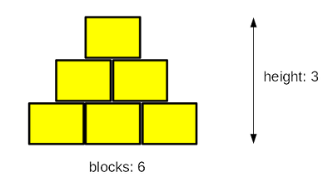
Your task is to write a program which reads the number of blocks the builders have, and outputs the height of the pyramid that can be built using these blocks.
Note: the height is measured by the number of fully completed layers - if the builders don't have a sufficient number of blocks and cannot complete the next layer, they finish their work immediately.
Test your code using the data we've provided.

Test Data

Sample input: 6
Expected output: The height of the pyramid: 3

Sample input: 20
Expected output: The height of the pyramid: 5

Sample input: 1000
Expected output: The height of the pyramid: 44

Sample input: 2
Expected output: The height of the pyramid: 1

